Observation and reflection booklet
Name: _____________________

TEaching positive Behaviours for learning: Routines ITaP
"The smallest act of kindness is worth more than the greatest intention" Khalil Gibran
Pre-task - Readings Note Sheet (On CANVAS)
Bennett (2016) - The 3Rs of the Behaviour Curriculum
Routines | Responses | Relationships

Wubbels (2011) – 6 classroom management approaches
Behavioural | Internal Control | Ecological
Discourse centred (U.K spelling) | Curricular | Interpersonal
Pre-task: From school website research, write down the school’s mission statement and core values and rules, locate and download school policy
I have located and downloaded school policy related to behaviours for learning YES/NO

School Mission Statement

Core Values and rules

I have completed the pre-survey YES/NO

Pre-task in school. List all the routines you can identify in this first week. See below to help you define those routines:
Entry to classrooms
Exit from classrooms
Answering/asking questions
Transitions from one activity to another
Toilet breaks
Getting attention
Collecting or distributing equipment
What to do when you need help (the pupil)

You can add rows to this list and type into the box to outline the routine and the roles of the pupils and adults.

Pre-task -school-based: Classroom Layout
Draw your classroom and label different areas. Write down how the layout supports routines.

Day 1: BfL ITaP Video Observation 1Proforma 1: The Tune In
Reception: Manage behaviour with routines and consistency
Adapted from Chambers (2011)
Surprises  (What happened that you were not expecting and will need to be taken into future consideration and researched further?) | Patterns  (What did you notice that repeated several times across the experience and may be an important point for consideration? What looks the same for all learners?)
Connections  Can you make connections to Bennett’s 3Rs (2016) and Wubbels (2011) 6 approaches to classroom management | Puzzles  (Did anything happen during the experience that did not make sense and needs to be researched further or discussed with an expert?
Adaptive Teaching:
Did you notice any pupils that required specific approaches, tailored to suit their needs?

Key take aways to ask about, action or consider in your future practice. (MS although this video is not the most recent it demonstrates this teacher’s approach to setting up routines at the start of the year. We may disagree with some of her strategies and approaches, but observe to be reflective and analytical.)

Day 1 Key-takeaways and reflective notes (consider your current philosophy regarding encouraging positive behaviours for learning).

Space for notes from Chaplain (2018) reading (concentrate on preventative and reorientation strategies)

Day 2
Optional -for lecture notes
What behaviours for learning do you want to encourage or would like to see? | What behaviours do you want to teach, solve, learn how to respond to?
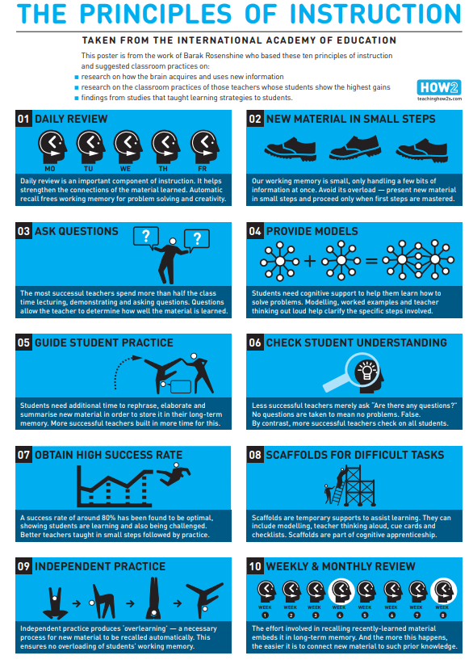
Day 2 Observation Proforma 1: The Tune In Adapted from Chambers (2011)
This proforma captures a first look, general or superficial deconstruction of a ROUTINE - entering the classroom.
Surprises [content/aspects of the routine that were unexpected and may need investigation or explanation with mentors] |  | Patterns [repeated aspects of the routine that would indicate importance and relevance]
Connections [aspects of the routine that connect to module learning and research to help explain them] |  | Puzzles [aspects of the routine that have created questions you would like to discuss and explore further]  Form has a second page
Key take aways to action in my own practice:

Adaptive practice:
How did/ do you think an entering the classroom routine would be different for different pupils?

For learners with specific learning needs?

For learners whose first language is not English and they are new to learning English?

Consider how to be culturally aware and responsive.

Further notes:

Day 2 - Plan for Building Successful Routines
Example for Lining up on CANVAS
Design
Describe
Demonstrate

Day 2 Scenarios to support role-play on CANVAS
Role-play script
Space to write script here

Day 2 Key-takeaways and reflective notes (consider your current philosophy regarding encouraging positive behaviours for learning).
Key Take aways

Paragraph regarding own current personal philosophy for teaching positive behaviours for learning.

Space for notes from Impact (2022) reading – key points of interest
Argyropulo-Palmer, A.-M. (2022) ‘Exploring the evidence base: The role of routines in creating an effective learning environment’, Impact, [online] (May). Available at: https://my.chartered.college/author/ann-marie-argyropulo-palmer/ (Accessed: 16 July 2025).
Harper, J. and O’Brien, K. (2015) ‘Establishing routines’, in Classroom routines for real learning: Daily management exercises that empower and engage students. Markham, Ontario: Pembroke Publishers, pp. 7–14.

Day 3 School-based Observation Proforma 1: The Tune In Adapted from Chambers (2011)
This proforma captures a first look, general or superficial deconstruction of a routine. OBSERVATION / expert modelling chosen morning routine:
Surprises [content/aspects of learning and lesson that were unexpected and may need investigation or explanation with mentors] |  | Patterns [repeated aspects across the lesson learning that would indicate importance and relevance]
Connections [aspects of learning or lessons that connect to module learning and research to help explain them] |  | Puzzles [aspects of learning and lessons that have created questions you would like to discuss and explore further]
Key take aways to action in my own practice:

Adaptive practice:
How did this learning/lesson look different for different pupils?

Further notes:

Day 3 School-based Observation Proforma 1: The Tune In Adapted from Chambers (2011)
This proforma captures a first look, at routines in a different key stage/age range.
Surprises [content/aspects of learning and lesson that were unexpected and may need investigation or explanation with mentors] |  | Patterns [repeated aspects across the lesson learning that would indicate importance and relevance]
Connections [aspects of learning or lessons that connect to module learning and research to help explain them] |  | Puzzles [aspects of learning and lessons that have created questions you would like to discuss and explore further]
Key take aways to action in my own practice:

Adaptive practice:
How did this learning/lesson look different for different pupils?

Further notes:

Day 3 EXPERT SUPPORT AND COACHING (45 mins -1 hour)
Student notes from meeting the school’s behaviour for learning lead.

Daily Reflective Notes - any further thoughts?
Include any feedback from low-stakes practise of routine. What went well and why? Next steps?

Tasks to complete:
Complete pre-tasks for Thursday. Reading: Reid, J. (2017) ‘Emotional development and approaches to classroom management’, in Colley, D. and Cooper, P. (eds.) Attachment and emotional development in the classroom: Theory and practice. London: Jessica Kingsley Publishers, pp. 249–264.
Programme: BBC iPlayer ‘Don’t exclude me’ Part 1 focusing on Jake and Jade CT (1 hour 15 mins)
You can do this reading and observation task on Day 3 and 4. Proforma on next pages.
Add any key notes below:

Day 4 School-based
Initial Reflection of the morning routine responding to verbal feedback. (Brief)

Day 4 School-based Observation Proforma 2: Impact on Learners/Learning

This proforma helps to investigate the relationship between teaching and learning and to identify the cause and consequence of approaches and responses that you may see deployed in the classroom.
Learning Objective:  Identify and explain the role and benefits of classroom routines in establishing shared values that contribute to a positive behaviours for learning culture (social, emotional and academic). |  | Focus for observation:  OBSERVATION of a lesson in base class  Please focus on subject specific routines. (Consider how the lesson starts, resources and the management of these, class layout, transitions, groupings, partners, talk routines, how to answer questions, including all learners).
Behaviours/Actions/Approaches  Stimulus  (Consider this for both the class teacher and the pupils). |  | Impact on learning  Response
You can add rows
Adaptive Teaching:
How does this look different for different learners?

Key take aways to ask about, action or consider into your weekly meeting or/and further practice:

Further notes or questions for the post-lesson reflection:

Post-lesson REFLECTION with the class teacher.

Day 4 Weekly Meeting -access from the itt-placement website
https://www.itt-placement.com/pgce-primary-5-11/mentoring-process.php
EXPERT COACHING - Weekly Meeting (1 hour)
RECEIVE FEEDBACK – (formative assessment) – critically discuss and reflect upon progress made so far with agreed routine. Agree and set actionable targets for improvement/ next steps. Use End of ITaP Assessment of Progress document to support with setting actionable targets.
If competent at practised routine, agree a different routine for the following week and continue this observe -practice -review reflective cycle.

Student Teacher Name: |  | Phase:  (Term for Salaried):
ITT Mentor: |  | Weekly meeting number:
Establishment: |  | Date: |  | Checklist for weekly meetings: Have you?
Before the Meeting:  Review progress towards targets agreed at previous weekly meeting OR targets set in any intervention/cause for concern/at risk action plan. |  |  |  | To check the box –double click (left) the square then ensure “default value” = checked. OK
Review of Target 1:  Review of Target 2:  Review of Target 3: |  |  |  | Reviewed feedback from lesson analysis forms and used this to focus discussion?  Drawn on the ITE Curriculum to support training and targets?  Identified progress against previous targets with a focus on the impact on pupils?  Set appropriate targets for development for the coming week?  Ensured some targets focus on subject specific knowledge and pedagogy?  Discussed the student teacher’s timetable and ensured it is sufficiently broad to meet their needs?  Supported the student teacher’s understanding of different pupil needs?  Checked the content of the QTS Training and Development file?  Checked planning and evaluation in the School Experience file?  Where appropriate, reviewed targets from an intervention action plan/CfC or an At Risk Plan?
At the Meeting:
Discuss and note the knowledge and understanding you have gained this week (including from any LJMU curriculum sessions), and how your practice has developed as a result? Make brief notes about your training discussion with your ITT Mentor.

Agree Specific Targets for Development to improve impact on learning (Targets should be specific and capture small steps). Targets should include subject knowledge targets. Please refer to the subject specific ‘Guidance for observation and target setting’ (in section B at www.itt-placement.com).
Target 1:

Target 2:

Target 3:

Agree actions to be taken to address each target:

Work on Target 1 by

Work on Target 2 by

Work on Target 3 by

NB: A copy of each Weekly Meeting proforma must be stored by the Student Teacher in Sub Folder 1 of the QTS Training and Development File and a copy given to the ITT Mentor. It is the student teacher’s responsibility to type up the forms.
Day 4 Daily Reflective Notes

Reading task:
The Kindness Principle Chapter 8 Whitaker, D. (2023) Conflict resolution, de-escalation and the power of language

Observation Proforma 2: Impact on Learners/Learning ‘Don’t Exclude Me’
Days 3 and 4
This proforma helps to investigate the relationship between teaching and learning and to identify the cause and consequence of approaches and responses that you may see deployed in the classroom.
BfL Learning Objective:  Identify and explain the role and benefits of classroom routines in establishing shared values that contribute to a positive behaviours for learning culture (social, emotional and academic). |  | Focus for observation:  ‘Don’t exclude me’ is available on bbciplayer – series 1, episode 1).  Please focus on the interactions between pupil Jack and teacher Jade.  (Relationships, routines and responses)
Behaviours/Actions/Approaches (by either Jack or Jade)  Stimulus |  | Impact on learning and teaching (Jack and Jade)  Response
Adaptive Teaching:
How does this look different for different learners?

Consider the advice given by the expert and how is this adaptive practice.

Behaviours for learning are developmental and include: social, emotional and academic.

Key take aways to ask about, action or consider into your weekly meeting or/and further practice:

Further notes:

Day 5 Observation Proforma 1: The Tune In Restorative Conversation Adapted from Chambers (2011)
This proforma captures a first look, general or superficial deconstruction of a lesson, approach or subject.
In this case, a restorative approach.
Surprises [content/aspects this restorative approach that were unexpected and may need investigation or explanation with mentors] |  | Patterns [repeated aspects across the observed restorative conversation that would indicate importance and relevance]
Connections [aspects of this approach, restorative practice, that connect to module learning and research to help explain them] |  | Puzzles [aspects of restorative practice that have created questions you would like to discuss and explore further]
Key take aways to action in my own practice:

Adaptive practice:
How did this learning/lesson look different for different pupils?

(Consider how you could have a restorative conversation with younger/older pupils. What would you need to consider? What about this practice where one or both pupils have specific learning needs or English as an additional language?)

Remember, the term EAL includes those children with two or more languages that they are fluent with, one may be English or not, new arrivals with little or no English, very young children who are still learning a home language and a new language)

Further notes:


Behaviours for Learning: End of ITaP Assessment of Progress
General mentors, please use your assessment evidence from this week to identify the outcomes that the student teacher is consistently demonstrating.
Student Name: | School:
General Mentor: | Year Group:

Key learning by the end of the ITaP. The student teacher: | Consistently demonstrating | Not yet consistently demonstrating
Practises the routine, planning for unexpected circumstances.
Practises the routine, being mindful of their own responses (self-regulation) to those not following the rules and routines.
Is clear with instructions when leading/ teaching the routine.
Considers the use of voice when explaining the routines and reorientating children to follow the rules. Considers clarity, having a deeper tone, and a steady pace.
Is listened to (demonstrates kind leadership) when expecting a routine to be established and followed.
Is able to recognise when a pupil needs support to self-regulate and follow a routine
Is developing and using strategies e.g., reorientation strategies, restorative practices, for those children not focusing on the routine.
Uses positive language and encouragement for those off task.
Uses strategies e.g., positive encouragement and praise, to enable all children to have high expectations of the routine.
Provides children with feedback regarding how well they are following the routines and making these a positive habit. (Feedback should relate to learning and achievement – social, emotional and academic)
Uses preventative strategies considering antecedent strategies and conditions where pupils can more easily self-regulate (trauma-informed) to encourage focused learning. (Classroom layout, organisation, preparation and planning for example)
Please use the outcomes above to identify two targets for the student teacher to prioritise during block placement
Target 1

Target 2

