ITaP (1) Behaviour Management
Intensive Training and Practice Booklet
This booklet is designed as a companion for establishing the foundations and skills in effective behaviour management in phase 1 of your training.
“It is the teacher’s own behaviour that has the most impact on the classroom.” (Dix, 2017)
Regarding effective behaviour management, “Pupils achieve more academically and socially; time is reclaimed for better and more learning; staff satisfaction improves; retention is higher; recruitment is less problematic.” (Bennett, 2017)

.”
Tom Bennett (2010)

Introduction
What is an Intensive Training and Practice element (ITaP)?
An intensive training and practice (ITaP) element in teacher education is designed to give trainees feedback on foundational aspects of the curriculum where close attention to and control of content, critical analysis, application and feedback are required. It provides an opportunity to intensify the focus on specific, pivotal areas. Intensive training and practice should also build powerfully on the link between evidence-based theory and practice. This means that intensive training and practice will need to be led and supported by an appropriate range of experts and delivered over a 5-day period.
For further information please read: ITT Market Review
What is the role of an ITaP?
The role of an ITaP is to strengthen the link between evidence and classroom practice. Some elements of intensive training and practice are conducted at university and then will need to take place in a school environment to consolidate practice. The role of the intensive focus may for example include the use of approximations of practice, rehearsal and is very much delivered in partnership with LJMU as the ITT provider.
For further information please read: Government Response to the ITT Market Review
ITaP - Focus on the 3Rs of the Behaviour Curriculum (Behaviour management)
This ITaP uses Bennetts (2016) ‘Developing behaviour management content for initial teacher training (ITT)’ recommendations. The principal aim of this working group was to ensure that every teacher receives a core minimum of the best training available to them in order to be as classroom-ready as time and circumstances permit. In line with this, the behaviour management ITaP will emphasis practicality by following Grossman’s model (2018) below, for teaching core practices: introduction, analyse, prepare, enact and assess. This will involve observation, practise and review.
Bennett’s (2016) recommendations complement our university curriculum as the DfE (2019) ITT Core Content Framework (CCF)has been designed to support student teachers in 5 core areas including behaviour management. The CCF is a minimum benchmark for ITT providers and throughout their Initial Teacher Education at LJMU, students will build on this introduction ITaP to managing behaviour.
Research informed practice
The research that underpins the principle of an ITAP is defined as an exploration of “identifiable components (fundamental to teaching and grounded in disciplinary goals) that teachers enact to support learning. Core practices consist of strategies, routines, and moves that can be unpacked and learned by teachers” (Grossman et al., 2018 p. 4). The ITAP is an intensive period of focused and pivotal practice and at the right time.
Guidance page 27 - https://assets.publishing.service.gov.uk/government/uploads/system/uploads/attachment_data/file/1119026/ITT_Provider_Guidance_Stage_2.pdf

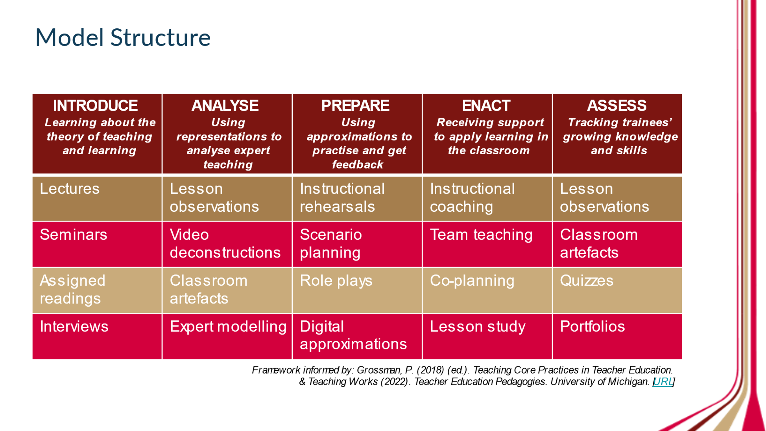

Why is Behaviour Management an ITAP focus? (Intent)
Part of the LJMU ITE vision is to develop reflective teachers who want to have an impact on our local schools and who are committed to social justice. Evidence shows us that effective classroom and behaviour management plays a crucial part in teaching and motivating children to learn. Classroom management is one of six key components for great teaching (Coe et al 2014) and behaviour management is a part of this. Pupil behaviour is key to the success of most classroom outcomes (Bennet 2016 -summary)and it is crucial that our teachers have the knowledge and skills to manage behaviour for learning effectively.
Our own assessment data indicates that student teachers are often worried about managing behaviour; this fits with the larger picture of early career teachers concerns regarding positive behaviour management(NEU 2023). For these reasons, all primary and early years student teachers undertake intensive training and practice (ITaP) in behaviour management (classroom and behaviour management to optimise learning). This allows them time, space and support to focus on developing their knowledge and skills in this key aspect of teaching.

What does this mean for the university and school partners?
Universities and their school partners will work together to deliver the ITaPs and ensure that all student teachers make progress with respect to their knowledge of and application into practice in key areas. This will mean that student teachers will benefit from focused days in university/centre-based training. These will be progressive and prepare students for managing behaviour at this phase of their learning/ teaching and how to plan for behaviour for learning. School partners will support student teachers by facilitating them to observe experienced teachers and teach themselves in an early years/ primary class relevant to their course. School mentors will support with co-planning, observing student teaching, assessing student progress and discussing achievements and areas for development.
This ITaP will focus on preparing student teachers through practical experiences at this initial stage of training. They will need opportunities to develop practical skills, in school, within a supportive environment. Working together, students will be introduced to theory at university, they will have opportunities to observe and reflect on recorded practices, analyse videos and podcasts, and practical opportunities to plan and practise scripts through role-play with feedback, considering different scenarios. There will be discussion forums, to share different perspectives, encouraging collaborative critical and creative thinking in a caring trustworthy environment. School practice will be carefully organised and planned to include observations of expert teachers, discussions, reviewing practices, analysing policies, opportunities to practice and enact. Students will be assessed throughout, with more formal assessment in their school placement (lesson observation of their practice).

What constitutes ‘best practice’ in behaviour management?
University-based sessions teach that behaviour management is a part of classroom management. It is important that the student teachers develop classroom settings that optimise safety, wanted behaviours and a shared whole school ethos for pupils to be motivated to learn. Behaviours for learning need to be taught and it should not be expected that all pupils have the same understanding and skill set when they start school. Bennett (2020) advocates that being well-behaved is a combination of skills, aptitudes, habits, inclinations, values and knowledge.
For student teachers to be ready to embark on teaching pupils strategies for self-regulation and motivation to learn, they must first analyse their own behaviours for learning (BfL). They will be in a better position to teach the pupils if they have positive good behaviours themselves. As part of our ambitious curriculum, students are taught that adaptive practice will be important with managing behaviour and how using trauma-informed behaviour management practices can support all learners. A one size policy and practice does not fit all learners. For a safe and secure learning environment, the importance of classroom organisation, routines and preventative measures are considered first.
Student teachers will then consider different strategies to respond to unwanted behaviours, after routines have been established. Students will learn how to refocus the class and the appropriate use of rewards and sanctions will be analysed. Following whole school policy is paramount as consistency is key (Dix 2017, EEF 2019). Ofsted (2014) reported that low-level disruption caused by persistent disruptive behaviours (e.g., shouting out inappropriately) caused a frequent loss in learning time. This can be frustrating for all teachers, parents and carers and important that student teachers have strategies to prevent these low-level disruptions.
However, without strong and respectful relationships, it can be difficult to implement routines and responses in line with school policy. Student teachers will reflect on their role as professionals and how to develop appropriate relationships to have the maximum impact on learning. For example, the importance of strong subject knowledge and pedagogical practices will support BfL and gaining respectful relationships.
At LJMU it is our mission to ensure that every teacher receives a core minimum of the best training available to them in order to be as classroom-ready as time and circumstances permit (Bennet 2016). EEF (2019) states that misbehaviour in lessons is something that has been documented by teachers for centuries. While most pupils in most lessons are well-behaved, it’s a major cause of stress for teachers and can have a lasting impact on the outcomes of the pupils in the class. There’s a clear need for school to have consistent and clear behaviour policies that promote positive behaviour in lessons.
Their 6 recommendations are:
- Know and understand your pupils and their influences
- Teach learning behaviours alongside managing misbehaviour
- Use classroom management strategies to support good classroom behaviour
- Use simple approaches as part of your regular routine
- Use targeted approaches to meet the needs of individuals in your school
- Consistency is key
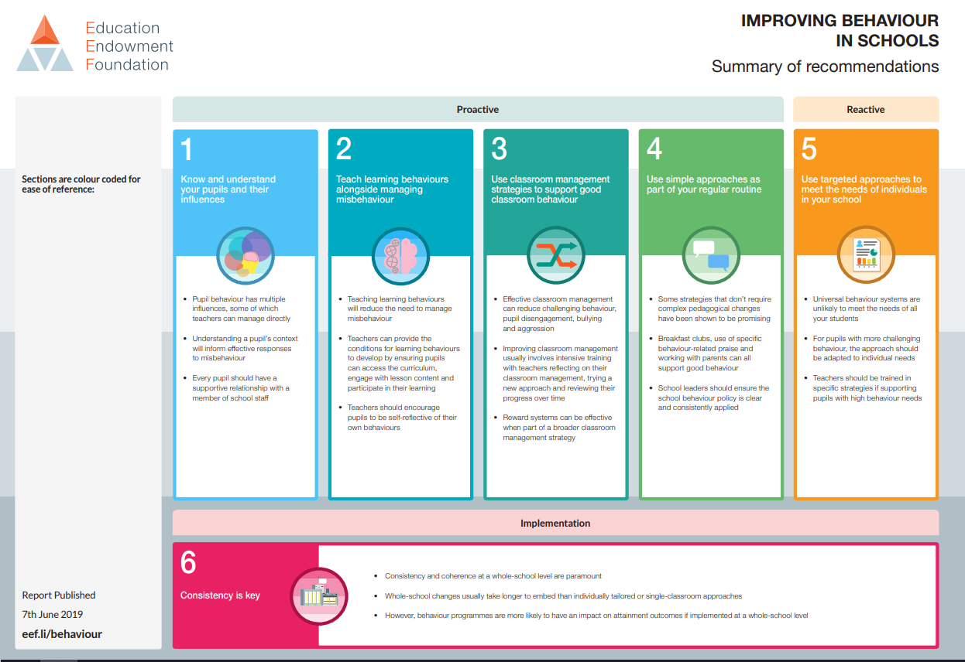

These recommendations compliment Bennett’s (2106) recommendations for developing behaviour management content for ITT, and our taught curriculum based on the CCF (2019) Core Content Framework. The ITT Core Content Framework, as with the Early Career Framework (ECF), has been designed to support student teachers’ development in 5 core areas – behaviour management, pedagogy, curriculum, assessment and professional behaviours. It is important to note that at LJMU the importance of all core areas impact on behaviours for learning.
Professional Studies sessions include: safeguarding, child protection, cognitive science and memory, learning to learn, self-regulation and metacognition, planning, observing and reflecting. In subject sessions, our professional studies curriculum is revisited modelling spaced practice and interleaving (a spiral curriculum).
This ITaP seamlessly fits in to our curriculum and is written with LJMU’s vision for our students, in mind:
LJMU ITE Vision
The vision of the LJMU partnership is to educate and empower passionate, evidence-informed teachers whose knowledge, skills and courage will transform lives. We strive to develop inquisitive, nurturing and reflective educators who personalise learning and are agents of change for our community, preparing children to be life-long learners and responsible global citizens.
Our ITE partnership promotes and demonstrates social justice, equity, diversity and inclusion, within and beyond classrooms. Our highly-skilled and research-engaged team is committed to excellence and collaboration and has embedded an effective and ambitious curriculum, thus ensuring that LJMU continues to be a leading provider of teacher education.
Further supporting this ITaP is the philosophy of behaviour expert and author, Paul Dix:
Dix (2018:184) states that ‘reflecting on starting point will show you that even when behaviour dips, you will have still travelled a considerable distance.’ Five pillars of practice that underpin effective behaviour policies:
- Consistent, calm and adult behaviour
- First attention for best conduct
- Relentless routines
- Scripting difficult interventions
- Restorative follow up Dix (2018:167-168)

The key texts for this ItaP are:
Bennett, T. (2016) Developing behaviour management content for initial teacher training (ITT) DfE
Bennett, T (2020) Running the Room: a teacher’s guide to behaviour John Catt Publishers
Below are other key readings.
Adams, K. (2018) Managing behaviour for Learning. In: Hansen, A. 4th ed Primary Professional Studies. London: Sage pp. 334-350
Bennett, T. (2017) Creating a Culture: How school leaders can optimise behaviour Crown Copyright
Chaplain, R (2018) Unit 3.4 Managing Classroom Behaviour. In: Cremin, T. and Burnett, C. 4th ed Learning to teaching in the Primary School Oxon: Routledge
Coe, R., Aloisi, C., Higgins, S., & Major, L. E. (2014) What makes great teaching. Review of the underpinning research. Durham University: UK. Available at: http://bit.ly/2OvmvKO.
Dix, P. (2017) When the Adult Changes: Seismic Shifts in School Behaviour Wales: Independent Thinking Press
EEF (2029) Improving Behaviour in Schools Education Endowment Foundation
Graham-Matheson, L. (2015) Essential theory for primary teachers: an introduction for busy trainees London: Routledge, Taylor & Francis Group
Kara, B. (2021) Diversity in Schools Corwin: London.
Ofsted (2014) Below the Radar: low-level disruption in the country’s classrooms Ofsted
Sackville-Ford, M. (2019) How might we frame ‘behaviour’ in primary schools? In: Carden, C. ed Primary teaching; learning & teaching in primary schools today. US: Sage pp. 243-260
Whitaker, D. (2023 The Kindness Principle Wales: Independent Thinking Press
Willingham, D. (2008)What will improve a student’s memory American Educator Winter 2008-9
Wubbels, T. (2011) An international perspective on classroom management: what should prospective teachers learn?, Teaching Education, 22:2, 113-131, DOI:10.1080/10476210.2011.567838
All readings should be available from LJMU’s library.

Implementation of the ITaP

The table below outlines the delivery of this carefully selected pivotal and foundational aspects of the planned training curriculum with a focus on behaviour and linked to the core content framework (CCF). Although there are opportunities to link theory and practice together during general teaching placements, the specific focus of an ITAP makes this link more obvious and gives greater opportunities for practice. The intention is to consolidate student teachers’ understanding of how the evidence base should shape their teaching practice, which is a concept that could be applied to any subject, phase or age range. Use of this model should also increase coherence between the theory that is taught and its practice in schools.

ITaP: The 3Rs of the Behaviour Curriculum -Routines, Responses and Relationships
Learning Outcomes
- To articulate the need for routines
- To take responsibility for specific daily routines

Day 1  14.11.23  Centre-based | Day 2  21.11.23  Centre-based | Day 3  28.11.23  Centre-based | Day 4  05.12.23  Centre-based | Day 5 (Equivalent)  Centre-based: Bridge unit  School based:  Monday Placements  Block Placement
PRE-READINGS - Bennet, T. (2016) Developing behaviour management content for initial teacher training (ITT) DfE  Wubbels, T. (2011) An international perspective on classroom management: what should prospective teachers learn?, Teaching Education, 22:2, 113-131,DOI:10.1080/10476210.2011.567838 | Read UNIT 3.4. Chaplain, R. in ‘Learning to Teach in the Primary School’ Ed Cremin and Burnett (2018)  Reading - Ofsted (2014) Below the Radar: low-level disruption in the country’s classrooms Ofsted | Paul Dix (2017) When the Adult changes everything changes: Seismic shifts in school behaviour Chapter 8  Restore, redraw, repair | Pre-task: watch BBC iPlayer ‘Don’t exclude me’ Part 1  How can we manage our most challenging pupils? Behaviour expert Marie Gentles brings her positive, practical approach to help teachers and parents keep children in the classroom. | BRIDGE UNIT  2 hours  Review the 3Rs of the behaviour curriculum  Prepare for school-based learning
INTRODUCE  09:00-10:00  LECTURE - Routines  CLASSROOM MANAGEMENT – PREVENTING UNWANTED BEHAVIOURS  Routines to prevent low-level disruption (unwanted behaviours)  10:00-12:00  SEMINAR/WORKSHOP  FOCUS ON ROUTINES  Assigned Readings  Tasks related to pre-reading Wubbel’s (2011) 6 approaches to classroom management AND Bennett’s (2016) 3R’s of the behaviour curriculum.  Routines  Responses  Relationships  Compare, contrast, find similarities.  ASSESS  Upload task to CANVAS and their Behaviour ITaP PORTFOLIO in their on-line QTS training and development files  ANALYSE  Video deconstruction  School Routines -make a list, connections to readings  ANALYSE  Classroom artefact  Pictures from real school setting -compare differences of Early Years setting to KS1  PREPARE  Scenario Plan  In pairs, students design their own KS1 classroom  (With reference to readings and analysis, plan a KS1 classroom – could use a software programme)  ASSESS  Upload Classroom plan to their Behaviour ITaP PORTFOLIO in their on-line QTS training and development files | INTRODUCE  09:00-10:00  LECTURE -routines and responses  BEHAVIOUR MANAGEMENT – MANAGING UNWANTED BEHAVIOURS (REORIENTATION AND REACTIVE)  Introduce – Theory  (Humanist, behaviourist, cognitivist, constructivist)  Underpinned by trauma-informed, anti-prejudiced approaches  10:00-12:00  SEMINAR/WORKSHOP  PREPARE  Create 5 classroom rules that support a fictional school’s ethos  Discuss impact of too many rules (Dix 2017) and how many schools have 3 core rules.  Peer-review and evaluate. Re-write  Scenario -planning  Activity – sorting responses into: would do, would not and with rationale  ASSESS  Upload both tasks to CANVAS and their Behaviour ITaP PORTFOLIO in their on-line QTS training and development files | INTRODUCE  09:00-10:00  LECTURE – routines, responses and relationships  Developing professional relationships – MANAGING self  Activity – personal self-reflection using a ‘well-being’ wheel  (Links to our taught curriculum: self-regulation and metacognition, motivation and well-being)  References to Willingham, PACE and trauma-informed practices, Whitaker -regulate, relate, repair, Maslow, Rosenshine  10:00-12:00  SEMINAR/WORKSHOP  PREPARE  Practice scenario -what children/parents or carers/ other teachers may say about you  ASSESS  Upload task to padlet and their Behaviour ITaP PORTFOLIO in their on-line QTS training and development files  ANALYSE  Video deconstruction  Observe a restorative practices example video. Make notes on a tune-in observation form. In class discussion.  Prepare  Students are given a mentor feedback scenario with post-lesson discussion areas to develop. Activity – prepare scenario  With a peer, practise a conversation with a school ITT mentor in response to the stimulus. Plan a script. (Tricky conversations)  ANALYSIS  Video analysis Paul Dix -complete observation tune-it form | INTRODUCE  09:00-10:00  LECTURE – Implementing the 3Rs of the behaviour curriculum: policy and practice  (Theory to Practice)  VIDEO ANALYSE  Extract snippet from the pre-task programme -more challenging behaviours and de-escalation  Complete 3Rs observation Sheet  VIDEO ANALYSE  Debbie Breeze Ted talk -more challenging behaviours  Discussion and consideration of what more challenging behaviours are, as observed in bbc documentary and refection on Ted Talk.  Bennett(2107) Building a school Culture. Design, build, maintain. Video of Bennett regarding school policy and practice.  De-escalation, trauma informed Playfulness Acceptance Curiosity Empathy (PACE), Regulate, relate, repair (Whitaker (2023) and Establish Maintain Restore (EMR) (EEF 2019)  10:00-12:00  SEMINAR/WORKSHOP  ANALYSE  Document analysis/Classroom artefacts  School policy documentation.  Student analyses a school policy and complete a 3Rs proforma making connections to each of these. Working with a partner they compare and contrast policies and how present the 3Rs of the behaviour curriculum are.  ASSESS  Upload proforma to CANVAS and their Behaviour ITaP PORTFOLIO in their on-line QTS training and development files | School-Based  (See Day 5 school-based tasks in separate document for the ITaP). UG Y1 have curriculum PDAs to complete alongside ITaP work.  ANALYSIS (1hour 30 mins equiv.)  Getting to know the school and class  Locate school behaviour policy and complete document analysis on 3Rs proforma  ASSESS (1 hour)  Tracking trainees’ growing knowledge and skills-review of prior learning  In the first weekly meeting, student shares their portfolio with ITT mentor. This is to establish what the student already knows and has practised in a safe space.  ANALYSIS (1hour)  Draw classroom layout and make notes regarding class routines, rules and responses on the template grid in Day 5 booklet.  ANALYSIS (1hour)  LESSON OBSERVATIONS  EXPERT MODELLING  ENACT  INSTRUCTIONAL COACHING  Students observe experts, focusing on specific routines:  Start of day, transitions, end of day  If appropriate, expert narrates what they are doing and why (worked example)  Students make notes  ASSESS  Upload Lesson Observations to their Behaviour ITaP PORTFOLIO in their on-line QTS training and development files  ENACT (1 hour )  Student practises a specific routine e.g. morning routines (meet and greet), end-of-day routines, transitions throughout the day.  ASSESS  Student receives mentor feedback. Actions to improve can be noted in weekly meetings.  Continue to practise.  TEAM TEACHING  Students can work with the mentor or with their school partner (peer)  CO-PLANNING  Prior to the more formal observation, the school mentor can work with the student to check 3Rs are planned for in the lesson plan.  ASSESS (1 hour)  Once the student has had opportunity to practise routines, a more formal Lesson analysis can be conducted by the mentor– with a focus on routines, responses and relationships and how this had an impact on behaviours for learning.  Feedback and targets -post-lesson discussion and in weekly meeting  Practise and Re- enact as part of usual teaching practice, with weekly meeting reflections and post-lesson discussions.  Phase 1 review form will indicate progress made.
13:00-15:00  Routines  ANALYSE  Video Deconstructions  Watch two videos, KS1 and 2. Observe and reflect, recording notes onto a ‘tune in’ observation proforma.  ASSESS  Upload observation proformas to their Behaviour ITaP PORTFOLIO in their on-line QTS training and development files  EXIT TICKET  Review learning - add 3 key take-aways to the padlet. | 13:00-15:00  Routines and Responses  ANALYSE  Watch videos (Sue Cowley behaviour expert) and makes notes.  PREPARE  Scenario Plan/ approximations of practice  In groups of 6, prepare a role-play exemplifying routines using agreed classroom rules (prepared earlier)  Scenario enactment in a low-stakes environment. Recorded.  ASSESS  Upload role-play scripts and videos to CANVAS and their Behaviour ITaP PORTFOLIO in their on-line QTS training and development files  EXIT TICKET  Review learning - add 3 key take-aways to the padlet. | 13:00-15:00  Relationships  PREPARE  Listen to Naylor’s Natter Podcast – Just Talking to Teachers Paul Dix 12/6/2020  13:00-14:00 –  Complete a task reflecting on the podcast and to consider the effective use of restorative practices. (Structured proforma)  Contribute to a discussion board.  ASSESS  Constructive Feedback from tutor (expert) and peers  Upload feedback reflections to their Behaviour ITaP PORTFOLIO in their on-line QTS training and development files  EXIT TICKET  Review learning - add 3 key take-aways to the padlet. | 13:00-15:00  PREPARE  Revisit BBC iPlayer programme and previous content. Plan to talk about personal views at this stage regarding sanctions in primary school.  Debate for/ against e.g. the use of sanctions in primary school, facilitated in a P4C/ communities of practice approach.  Want to develop student teachers to be curious and questioning regarding approaches and what fits best with trauma-informed, anti-racist/prejudiced strategies.  ASSESS  Last responses and reflections of the provision so far and what they have learnt to ‘take-away’.  Uploaded on proforma to CANVAS  Place in their PORTFOLIO in their on-line QTS training and development files | School-based block placement  ASSESS - Interim Day  Time to reflect with peers regarding progress with 3Rs – set next steps  ASSESS  LTs to check students PORTFOLIOS (ITaP Day 5 and curriculum PDAs)
Indicative Gap Tasks  Read UNIT 3.4. Chaplain, R. in ‘Learning to Teach in the Primary School’ Ed Cremin and Burnett (2018)  Reading - Ofsted (2014) Below the Radar: low-level disruption in the country’s classrooms Ofsted  Reading - Leeming, J. Managing the Learning Environment in Hansen, A. (Ed) (2018) Primary Professional Studies, Learning Matters Ltd, 4th Edition (Chapter 19, pp 351- 366) | Indicative Gap Tasks  Readings – scripted behaviour scenarios  Planning group script  Read chapters 1,2 and 3 of Kara, B. (2021) Diversity in Schools Corwin: London  (Y1UG all have a hard copy) | Indicative Gap Tasks  The Kindness Principle Chapter 8 Whitaker, D. (2023) Conflict resolution, de-escalation and the power of language  Willingham, D. (2008) What will improve a student’s memory American Educator Winter 2008-9 | Indicative Gap Tasks  Complete their last thoughts after the debate as above.  Dix, P. (2017) Ch 10. Your behaviour Policy Sucks and Ch. 11 The 30-day magic  Whitaker, D. (2023) Ch 5. Behaviour Policy – Why bother?  Revisit ITaP sessions so far in readiness for the bridge unit | Indicative Gap Tasks  At interim day – set targets related to the 3Rs of the curriculum  End of placement – set targets for the next phase placement based on their end of phase feedback.

