Name: ______________________________

Attachment and Trauma-Informed Practice ITaP
Student booklet

Learning Outcomes

•To understand and accept that some children have experienced trauma and/ or adverse childhood experiences (ACEs)
•To recognise how trauma impacts the learning brain
•To be more equipped to support children in your school and classroom to feel safe and accepted
•To develop playful and curious practice
•To understand and enact the attributes of empathy
•To know your role boundaries and consider own well being

Focus on the PACE approach (playful, accepting, curious, empathy).

Day 1 Notes on sessions

Day 1 case study workshop

For each case study, think about:
What emotions the child may be feeling? Why?

What might be happening to their nervous system (Fight, Flight, Freeze, Fawn)?

What aspect/s of PACE could help them?

What could you try?

These two resources What about Me? (below) and What Survival Looks like in the Primary School (see Canvas) will help you to choose a suitable trauma informed response.

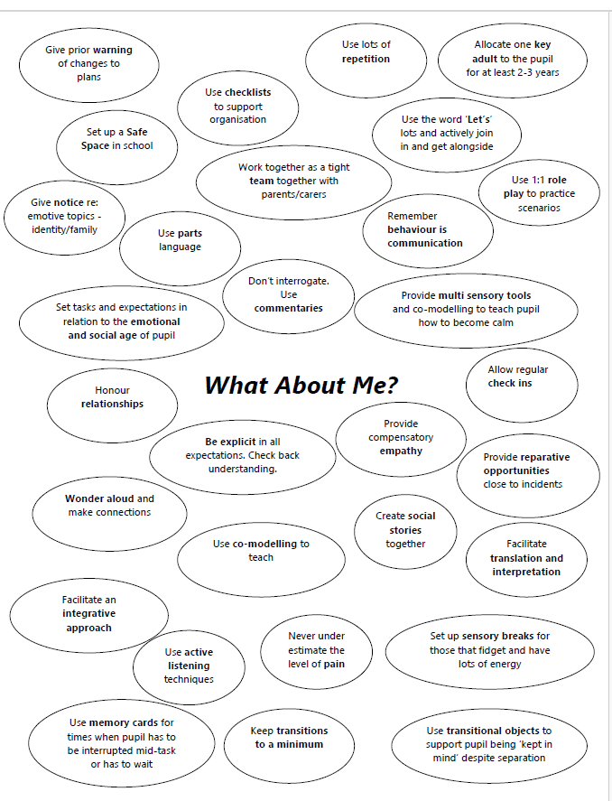

Day 1: key takeaways and reflective notes
Day 2 pre-reading and video: space for notes

Venet, A. S. (2019). Role-clarity and boundaries for trauma-informed teachers. Educational Considerations, 44(2), 3.

How the Body Keeps the Score on Trauma: https://www.youtube.com/watch?v=iTefkqYQz8g

Day 2: key takeaways and reflective notes

School-based task 1: Brain soother plan

Brain breaks/ Brain soothers
Please ensure that you discuss your two choices with your mentor. Make amendments if needed.

Description of brain soother chosen | Reason for choosing this brain soother | Resources needed | Timings of the day when you want to introduce the brain soother | Mentor sign off
1.

2.

Brain-soothers: Reflection on delivery in school and any photos (not of pupils) for Friday’s presentations
Feedback from teacher on brain-soothers

School based task 1 2 brain breaks/ soothers
To do | Comments | Signed by mentor
Planned 2 brain breaks/ soothers. Discussed with the mentor prior to the day. Completed.

End of day discussion with mentor.

Student teacher reflection

School-based task 2: belonging lesson plan (upload a mind map and lesson plan)

You will need to plan a whole lesson, with the end result being a display or photos of the activity. Make sure you have planned opportunities for autonomy, relatedness and competence to build intrinsic motivation (Ryan and Deci, 2020).

LO: To help pupils to feel a sense of belonging in the class through a PACE approach.

Feedback from teacher on school-based task 2
Lesson on belonging with a PACE approach (playful, accepting, curious, empathy)
To do | Comments | Signed by mentor
Planned lesson reflecting aspects of PACE with a focus on belonging. Discussed with the mentor prior to the day. Completed.

Post -lesson discussion with mentor.

Student teacher reflections – please fill in the ‘comments’ column on this form.

End of ITaP Assessment of Progress
General mentors, please use your assessment evidence from this week (e.g. weekly meeting, LAF, planning discussions) to identify the outcomes that the student teacher has demonstrated.
Key learning by the end of the ITaP | Demonstrated | Not yet demonstrated
The student teacher is able to discuss the impact of trauma on the brain and the body.
The student teacher is able to support children in the classroom to feel safe and accepted through strategies such as brain soothers.
The student teacher is able to support children in the classroom to feel safe and accepted through the belonging lesson.
The student teacher is able to define PACE (playfulness, acceptance, curiosity, empathy) and discuss how they developed this in the belonging lesson.
The student teacher has evidence of the brainsoothers (task 1) ready to explain the impact of the ITAP on their classroom back at university.
The student teacher has evidence of the belonging lesson (task 2) ready to explain the impact of the ITAP on their classroom back at university.
The student teacher recognises teacher -pupil role boundaries and considers their own wellbeing.

Please use the outcomes above to identify two targets for the student teacher to prioritise during block placement
Target 1

Target 2

Preparation for Day 5: Notes for Friday’s session – you will be creating a poster/ presentation on the school-based tasks– try to make connections with readings and think about how you can communicate the impact the school-based tasks had on you and your pupils.

Day 5: Reflection

Summarise the main messages from your presentation

What did you learn from watching others’ presentations? Any new learning or new connections?

