**THE IMPORTANCE**

**OF READING**

**A PRECOURSE SELF STUDY BOOKLET**

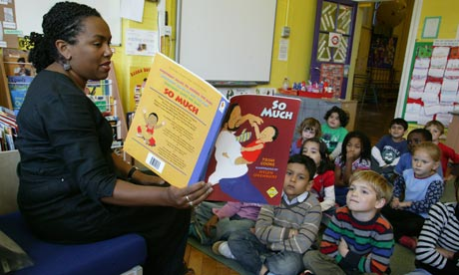

*Reading should not be presented to children as a chore, a duty. It should be offered to them as a precious gift.*

**Kate DiCamillo, (children’s author)**

*Reading widely and often increases pupils’ vocabulary because they encounter words they would rarely hear or use in everyday speech. Reading also feeds pupils’ imagination and opens up a treasure house of wonder and joy for curious young minds.*

**Department for Education, 2016:4**

**Congratulations on being offered a place on a primary course.**

As a primary teacher, one of your most important jobs will be to ensure that all the children you teach can read - and read well. Being able to read well is linked strongly to life chances; illiterate and semi-literate people tend to live in poverty and not being able to read limits their chances of escaping this. The implication of this for you as a future teacher is that you need to understand how to teach children to read well and have a professional knowledge and understanding of the barriers that may inhibit some learners.

**The Importance of Language Development and Phonological Awareness**

In 2016, The National Literacy Trust (NLT) published, ‘Ready to Read’ as part of its ‘Read on Get On’ campaign. This campaign draws on a substantial evidence-base that links strong language skills with the ability to read well. It states:

*without a step-change in support for children’s early language development, particularly for the poorest children, we will never achieve our goal of all children leaving primary school able to read well. Boosting children’s early language skills is therefore critical to narrow the attainment gap and improve the life chances of our poorest children.* (NLT, 2016:iv).

The NLT’s campaign is focussed on supporting **all** children to develop good language skills - listening, understanding a range of words, speaking, being able to use a range of words – before starting school. This is a long-term goal. It is very likely that you will be teaching children who are struggling with reading - for a range of reasons – and it is important that you fully understand the vital role that language development plays in this.

You may have heard of phonics or may even have taught it. Phonics teaching equips children with skills and knowledge to enable them to decode unfamiliar printed words and relies on pre-existing skills that allow children to discriminate between different sounds in words – some of which are very similar. The ability to listen well and talk extensively about experiences are important pre-skills that children need before formal phonics instruction begins.

During your training course, you will be looking at the different skills, knowledge and understanding that we need to teach children in order for them to become readers. However, without a wide vocabulary and a secure language base, phonics will not, on its own, produce secure readers. It is for these reasons that we would like you to complete the pre-course tasks outlined in this short booklet. These tasks will link to your subject knowledge sessions on the programme.

**Task 1**

Read the NLT’s Ready to Read (June 2016) publication. It is available here:

<https://literacytrust.org.uk/policy-and-campaigns/read-on-get-on/>

<https://cdn.literacytrust.org.uk/media/documents/Read_On_Get_On_Strategy.pdf>

Focus particularly on **chapter 2** and note your responses to the following questions:

*What does the data tell us about children with below average vocabulary development? How does this impact on their reading attainment?*

|  |
| --- |
|  |

*Why is this the case?*

|  |
| --- |
|  |

*What is language comprehension?*

|  |
| --- |
|  |

***Notes***

**Task 2 – Children’s language development**

Now focus on chapter 3 and note your response to the following questions.

*What influences children’s language development?*

|  |
| --- |
|  |

*Thinking of the things that strongly influence children’s language development at a very early age, what kind of things could schools and teachers do to try to close any gaps?*

|  |
| --- |
|  |

***Notes***

**Task 3: Promoting Reading for Pleasure**

Research indicates that children who read for pleasure gain many benefits and are more successful academically. Research conducted by Teresa Cremin at the Open University, suggests that teachers can motivate and engage readers by widening their knowledge of children’s literature and reading aloud to children.

# Watch the following TEDx Talk

# ‘Why we should all be reading aloud to children’ by Rebecca Bellingham

<https://www.youtube.com/watch?v=ZBuT2wdYtpM>

*…and this short film:*

<https://www.youtube.com/watch?v=CEsx8bkq9v0>

If you are to be a true teacher of reading, you need to read to children frequently – right up to and including those in year six. If you are going to be able to do this with confidence, you need to know what children enjoy and what might appeal to them. You are therefore asked to develop your knowledge and understanding of children’s literature throughout the course. The task below will start you on this journey.

**Develop your knowledge of children’s literature by reading a selection of the following:**

1. At least one children’s ‘classic’ e.g. Alice in Wonderland; Gulliver’s Travels; The Railway Children
2. A selection of Traditional Tales.

Read the originals - available at these links: <https://www.cs.cmu.edu/~spok/grimmtmp/> and <https://www.worldoftales.com/fairy_tales/Perrault_fairy_tales.htm> l

1. Compare with more modern versions of the above – try the Seriously Silly Stories versions by Laurence Anhott and Arthur Robins
2. A range of nursery rhymes – you will need to know these
3. A selection of children’s poetry. A good place to start would be: <https://www.poetryfoundation.org/learn/children>

Look at some classics too, [try The Jumblies by Edward Lear](https://www.poetryfoundation.org/poems/54364/the-jumblies), The Highwayman by Alfred Noyes, The Visitor by Ian Serraillier, [Benjamin Zephaniah - Talking Turkeys](https://downloads.bbc.co.uk/rmhttp/schools/teachers/offbyheart/talking_turkeys_zephaniah.pdf)

6. A selection of books – both picture books and others – that have either won or been nominated for a Children’s Book Award in recent years. You should aim to read as many as possible and by a range of authors (in the long run this will aid your professional development significantly), but endeavour to read at least four at this point.

1. **Picture books – are they only for young children?**

Take a look at the following and think about their appeal. Who is the target audience?

Read the guidance on how to choose children’s literature available at the following links:

<http://blogs.nottingham.ac.uk/primaryeducationnetwork/2017/06/05/power-picture-books-primary-classroom/>

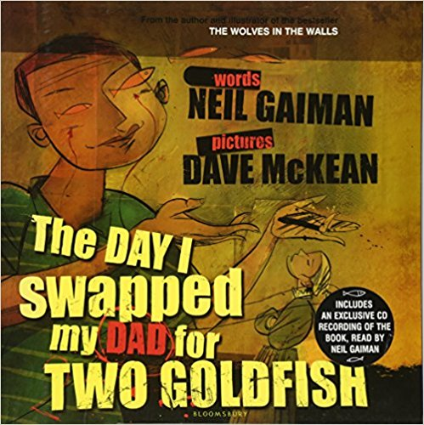 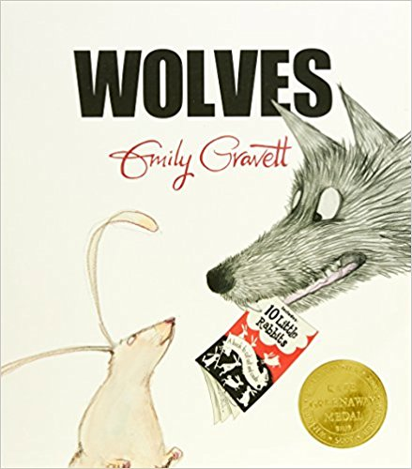 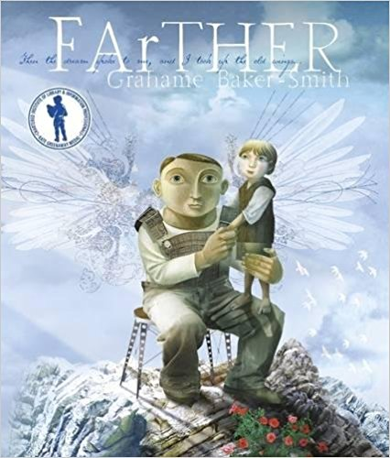

Books that represent our diverse society in an authentic and positive way. These are a good starting point:

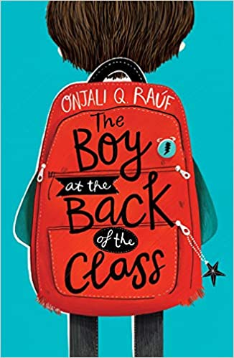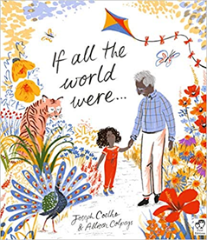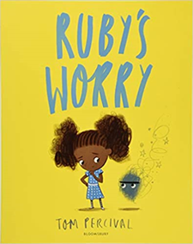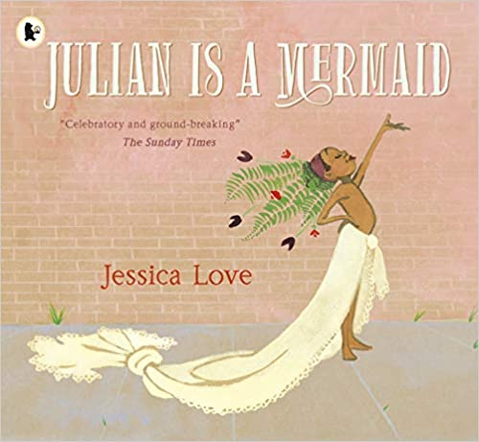 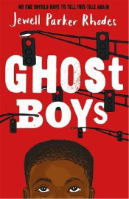  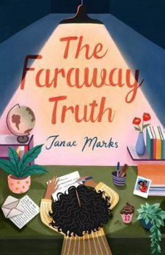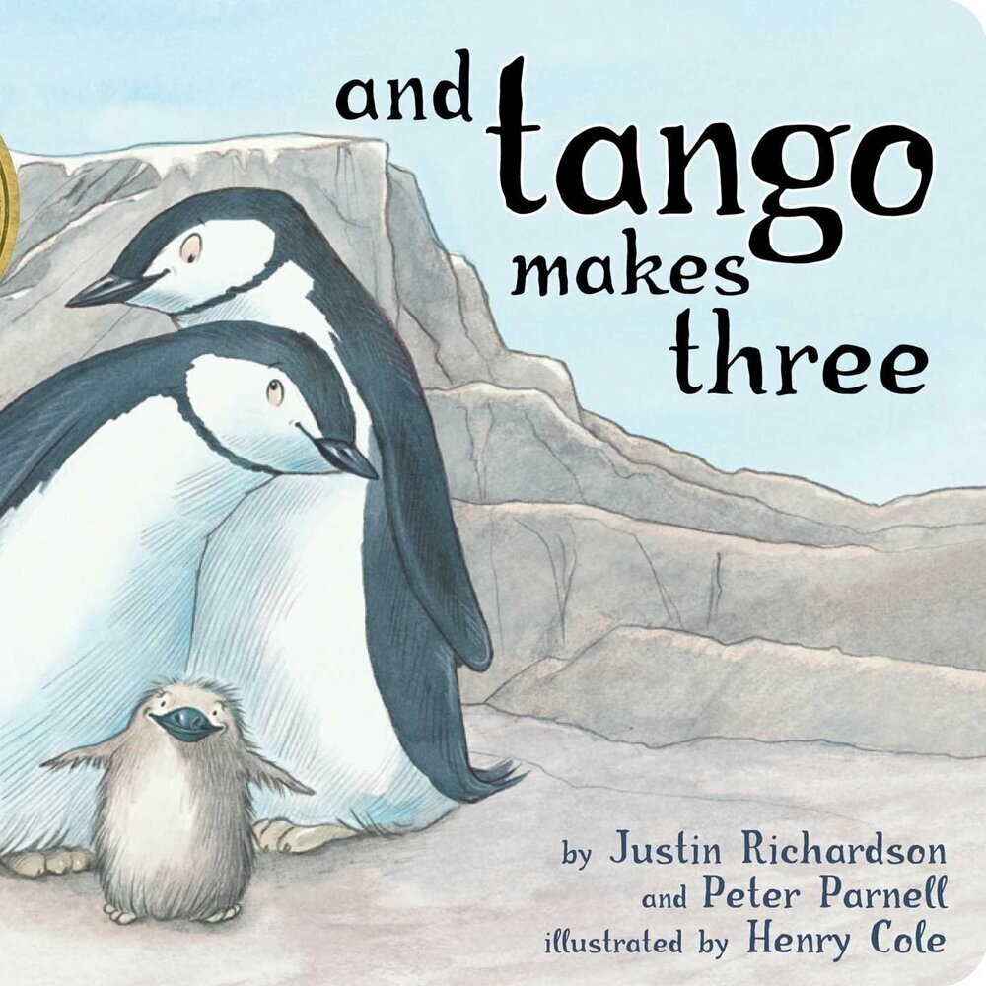

|  |  |
| --- | --- |
| **Children’s Book Awards** | |
| Whitbread Book Awards  Smarties Book Prize  Blue Peter Book Award  Carnegie Book Award | Kate Greenaway Medal  Children’s Book Awards  The Guardian Children’s Fiction Prize  Signal Poetry for Children |

**Useful Websites**

Carnegie Winners <http://www.carnegiegreenaway.org.uk/>

Books for Keeps <http://booksforkeeps.co.uk/>

**Authors – useful starting points**

|  |  |  |  |
| --- | --- | --- | --- |
| **How many of their books have you read?** | | | |
| John Agard  Janet & Alan Ahlberg  Joan Aiken  Bernard Ashley  Atinuque  Nina Bawden  Malorie Blackman  Quentin Blake  Raymond Briggs  Anthony Browne  Ruth Brown  John Burningham  Betsy Byars  Lauren Child  Joseph Coelho  Helen Cresswell | Berlie Doherty  Malachay Doyle  Anne Fine  Michael Foreman  Neil Gaiman  Leon Garfield  Morris Gleitzman  Armin Greder  Mary Hoffman  Sharna Jackson  Shirley Hughes  Ted Hughes  Pat Hutchins  Gene Kemp  Eva Ibbotson  Ursula Le Guin | Penelope Lively  David Mckee  Michelle Magorian  Margaret Mahy  Jan Mark  Bel Mooney  Beverley Naidoo  Edith Nesbitt  Mary Norton  Helen Oxenbury  Philippa Pearce  Terry Pratchett  Philip Pullman  Michael Rosen  SF Said | Maurice Sendak  Lemony Snicket  Catherine Storr  Jon Scieszka  Jean Ure  Cynthia Voigt  Martin Waddell  Jill Paton Walsh  Gillian Cross |